**SIDDAGANGA INSTITUTE OF TECHNOLOGY, TUMKUR**

Activity Based Learning Report

Activities

*on*

*Front End Design and Database Operations*

*Submitted in the partial fulfilment of the requirements for VI Semester*

Full Stack Development (OE78)

*Submitted by*

**PRANAMYA JAIN S P 1SI21EC073**



**Siddaganga Institute of Technology, Tumkur**

(An Autonomous Institution affiliated to Visvesvaraya Technological University, Belagavi, Approved by AICTE, New Delhi, Accredited by NAAC with A++ Grade, Awarded Diamond College Rating by QS I-GAUGE and ISO 9001:2015 Certified)

B. H. Road, Tumakuru-572103, Karnataka

**AY-2023-24**

**SIDDAGANGA INSTITUTE OF TECHNOLOGY, TUMAKURU - 3**



**CERTIFICATE**

This is to certify that activity-1 on “*Front End Design and Database operations*” is a bonafide work carried out by **Pranamya Jain S P (1SI21EC073)** of **VI** semester Bachelor of Engineering in **Electronics and Communication Engineering**, SIDDAGANGA INSTITUTE OF TECHNOLOGY during the academic year 2023-2024.

**Faculty** **Signature with Date**

**Dr. Pramod T.C**

**Assistant Professor**

**Dept of CSE, SIT**

**TABLE OF CONTENTS**

| **Sl.No** | **Particulars** | **Page. No** |
| --- | --- | --- |
| **1** | **Project Introduction** | **3** |
| **2** | **Project Code**  **(Important snippets)** | **4** |
| **3** | **Project Output (Screenshots)** | **8** |
| **4** | **PHP Programs** | **13** |
| **5** | **List of major HTML tags/ CSS properties/database connection and queries used** | **22** |

**INTRODUCTION**

Front-end development focuses on the visual and interactive aspects of a website or web application. It encompasses everything users see and interact with in their web browser. The primary goal of front-end development is to create an engaging, efficient, and accessible user experience.

Key Components of Front-End Development are:

1. **HTML (HyperText Markup Language)**:  
   HTML is the standard markup language used to create web pages. It provides the structure of a webpage by defining elements like headings, paragraphs, links, images, and other content.
2. **CSS (Cascading Style Sheets)**:  
   CSS is used to style and layout web pages. It controls the visual presentation of HTML elements, including their colors, fonts, spacing, and positioning.
3. **JavaScript**:  
   JavaScript is a programming language that enables dynamic and interactive web pages. It allows developers to create features like form validation, animations, and real-time updates without reloading the page.

**PHP(Hypertext Preprocessor)**:

PHP (Hypertext Preprocessor) is a widely-used open-source scripting language primarily designed for web development. It is particularly well-suited for server-side scripting to create dynamic web pages and interact with databases.

When it comes to database operations, PHP is commonly used to connect to various database management systems (DBMS) like MySQL, PostgreSQL, SQLite, etc. It provides functions and extensions that allow developers to perform tasks such as: Connecting to Databases, Executing Queries, Fetching Data, Handling Errors.

**PROJECT CODE**

1. **Navigation Bar (Navbar):**This code defines the navigation bar at the top of each page, providing links to different sections of the website.

<nav class="navbar navbar-expand-lg navbar-dark bg-dark">

<a class="navbar-brand" href="#">Sanctuary Name</a>

<button class="navbar-toggler" type="button" data-toggle="collapse" data-target="#navbarNav" aria-controls="navbarNav" aria-expanded="false" aria-label="Toggle navigation">

<span class="navbar-toggler-icon"></span>

</button>

<div class="collapse navbar-collapse" id="navbarNav">

<ul class="navbar-nav mr-auto">

<li class="nav-item">

<a class="nav-link" href="index.html">Home</a>

</li>

<li class="nav-item">

<a class="nav-link" href="About.html">About</a>

</li>

<li class="nav-item">

<a class="nav-link" href="Animal.html">Animals</a>

</li>

<li class="nav-item">

<a class="nav-link" href="Quiz.html">Quiz</a>

</li>

<li class="nav-item">

<a class="nav-link" href="#" data-toggle="modal" data-target="#contactModal">Contact Us</a>

</li>

</ul>

</div>

</nav>

1. **Modal for Contact Form:**This code defines a modal window that appears when the "Contact Us" link in the navbar is clicked.

<div class="modal fade" id="contactModal" tabindex="-1" role="dialog" aria-labelledby="contactModalLabel" aria-hidden="true">

<div class="modal-dialog" role="document">

<div class="modal-content">

<div class="modal-header">

<h5 class="modal-title" id="contactModalLabel">Contact Us</h5>

<button type="button" class="close" data-dismiss="modal" aria-label="Close">

<span aria-hidden="true">&times;</span>

</button>

</div>

<div class="modal-body">

<!-- Contact Form -->

<form>

<div class="form-group">

<label for="name">Name</label>

<input type="text" class="form-control" id="name" placeholder="Enter your name">

</div>

<div class="form-group">

<label for="email">Email address</label>

<input type="email" class="form-control" id="email" placeholder="Enter your email">

</div>

<div class="form-group">

<label for="message">Message</label>

<textarea class="form-control" id="message" rows="3" placeholder="Enter your message"></textarea>

</div>

</form>

</div>

<div class="modal-footer">

<button type="button" class="btn btn-secondary" data-dismiss="modal">Close</button>

<button type="button" class="btn btn-primary">Send</button>

</div>

</div>

</div>

</div>

1. **Quiz Form and JavaScript for Quiz Functionality:**This snippet includes the quiz form and the JavaScript code that handles quiz submission and scoring.

<form id="quizForm" style="display: none;">

<!-- Quiz questions and options -->

</form>

<script>

// JavaScript code to handle quiz starting, submission, and scoring

document.getElementById('startQuiz').addEventListener('click', function() {

document.getElementById('startQuiz').style.display = 'none';

document.getElementById('quizForm').style.display = 'block';

});

document.getElementById('submitQuiz').addEventListener('click', function() {

// Quiz scoring logic

});

</script>

1. **Volunteer Application Form:**This snippet defines the volunteer application form and includes JavaScript to handle form submission and display a confirmation message.

<form id="volunteerForm" action="#" method="POST">

<!-- Volunteer application form fields -->

</form>

<script>

document.addEventListener("DOMContentLoaded", function() {

const form = document.getElementById("volunteerForm");

const confirmationMsg = document.getElementById("confirmationMsg");

form.addEventListener("submit", function(event) {

event.preventDefault(); // Prevent form submission

// Additional form handling logic

// Display confirmation message

confirmationMsg.style.display = "block";

// Optional: Clear form fields after submission

form.reset();

});

});

</script>

1. **About Page Content:**This snippet shows the structure of the About page, including headings, paragraphs, and images.

<div class="container">

<h1>About Our Sanctuary</h1>

<p>

Lorem ipsum dolor sit amet, consectetur adipiscing elit. Nullam eu eros in odio consectetur dignissim. ...

</p>

<img src="about-image.jpg" class="img-fluid" alt="About Image">

<p>

Integer fermentum aliquam quam, nec fringilla justo malesuada vel. Phasellus hendrerit...

</p>

</div>

1. **Home Page Banner (Carousel):**This code snippet shows the implementation of a carousel (image slider) on the home page to showcase various images related to the sanctuary.

<div id="carouselExampleSlidesOnly" class="carousel slide" data-ride="carousel">

<div class="carousel-inner">

<div class="carousel-item active">

<img src="image1.jpg" class="d-block w-100" alt="...">

</div>

<div class="carousel-item">

<img src="image2.jpg" class="d-block w-100" alt="...">

</div>

<div class="carousel-item">

<img src="image3.jpg" class="d-block w-100" alt="...">

</div>

</div>

</div>

1. **Footer Section:**This snippet defines the footer section of the website, including copyright information.

<footer class="footer mt-auto py-3 bg-dark">

<div class="container text-center">

<span class="text-muted">© 2024 Sanctuary Name. All rights reserved.</span>

</div>

</footer>

1. **Bootstrap and JavaScript Dependencies:**These are the CDN links to Bootstrap and other JavaScript libraries used for responsive design and interactive features.

<!-- Bootstrap CSS -->

<link rel="stylesheet" href="https://stackpath.bootstrapcdn.com/bootstrap/4.5.2/css/bootstrap.min.css">

<!-- JavaScript and dependencies -->

<script src="https://code.jquery.com/jquery-3.5.1.slim.min.js"></script>

<script src="https://cdn.jsdelivr.net/npm/@popperjs/core@2.5.4/dist/umd/popper.min.js"></script>

<script src="https://stackpath.bootstrapcdn.com/bootstrap/4.5.2/js/bootstrap.min.js"></script>

**PROJECT OUTPUT (SCREENSHOTS)**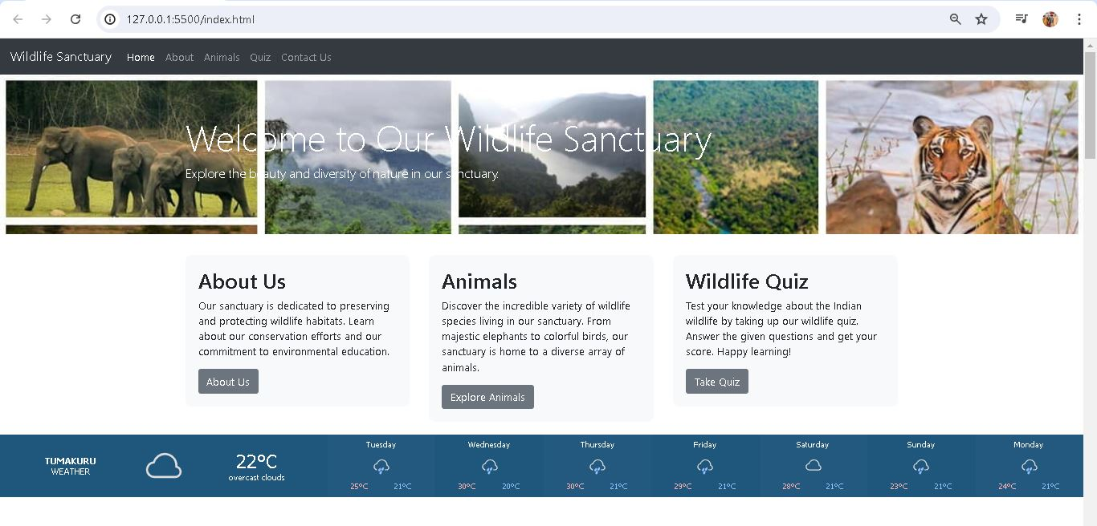

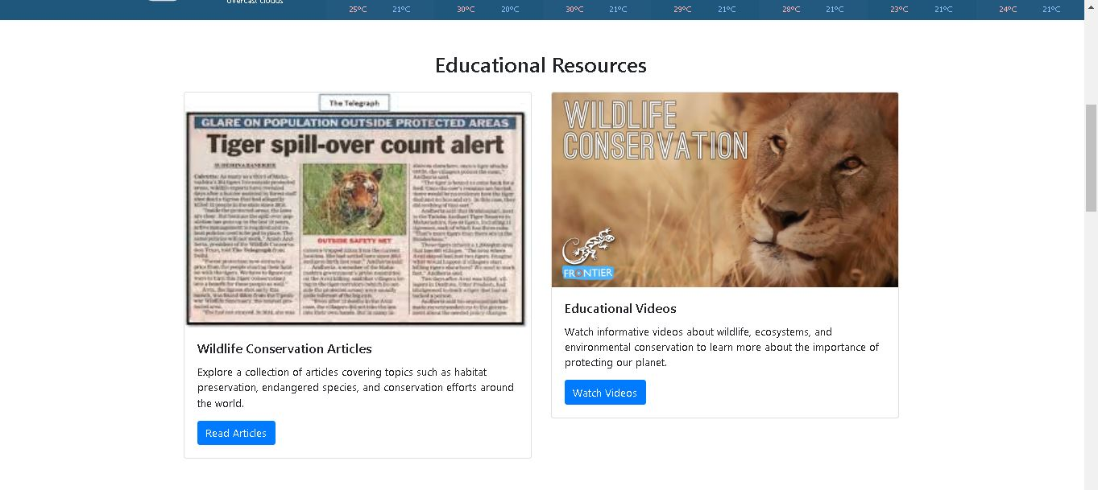

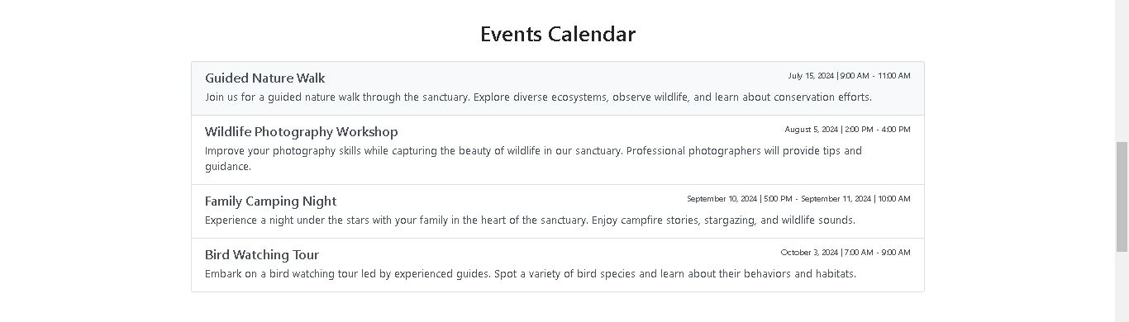

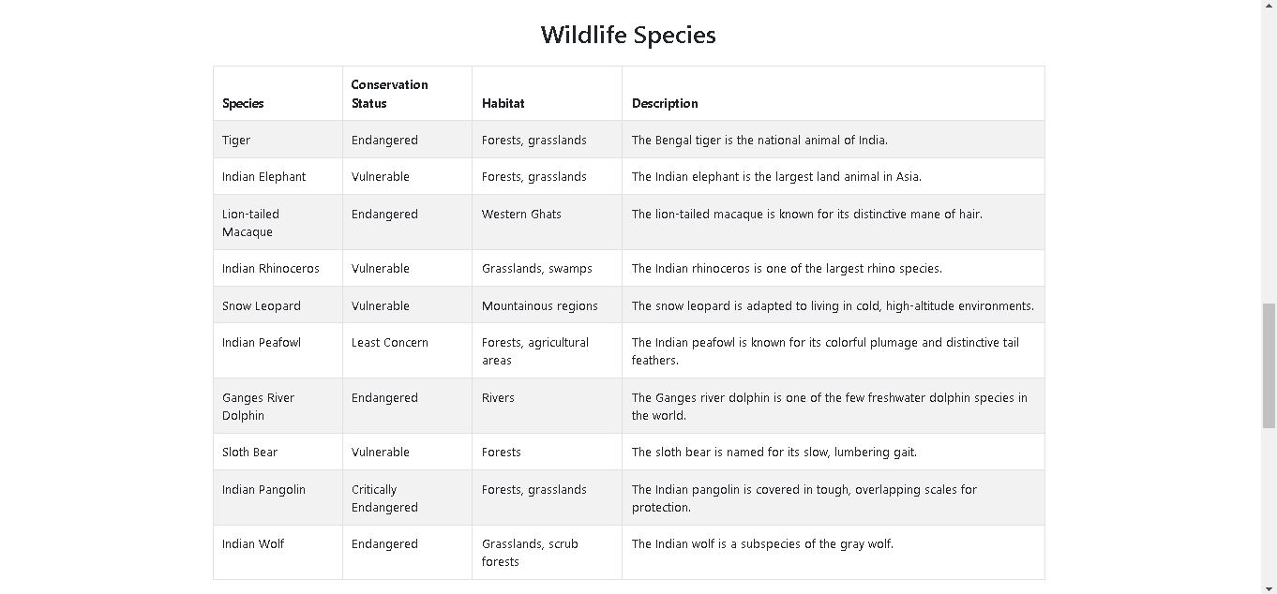

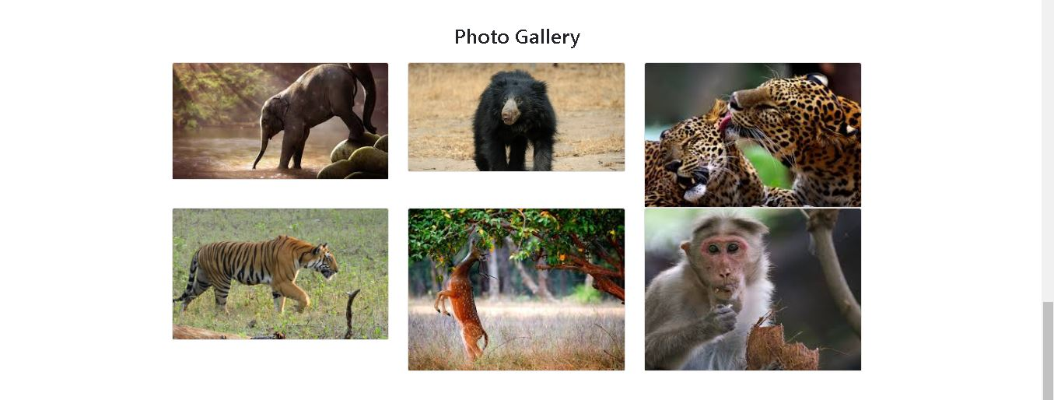

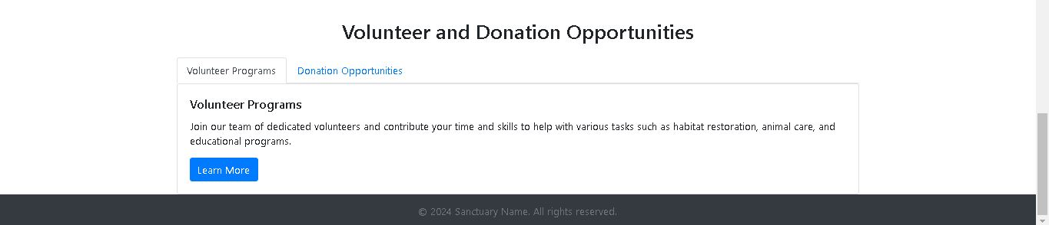

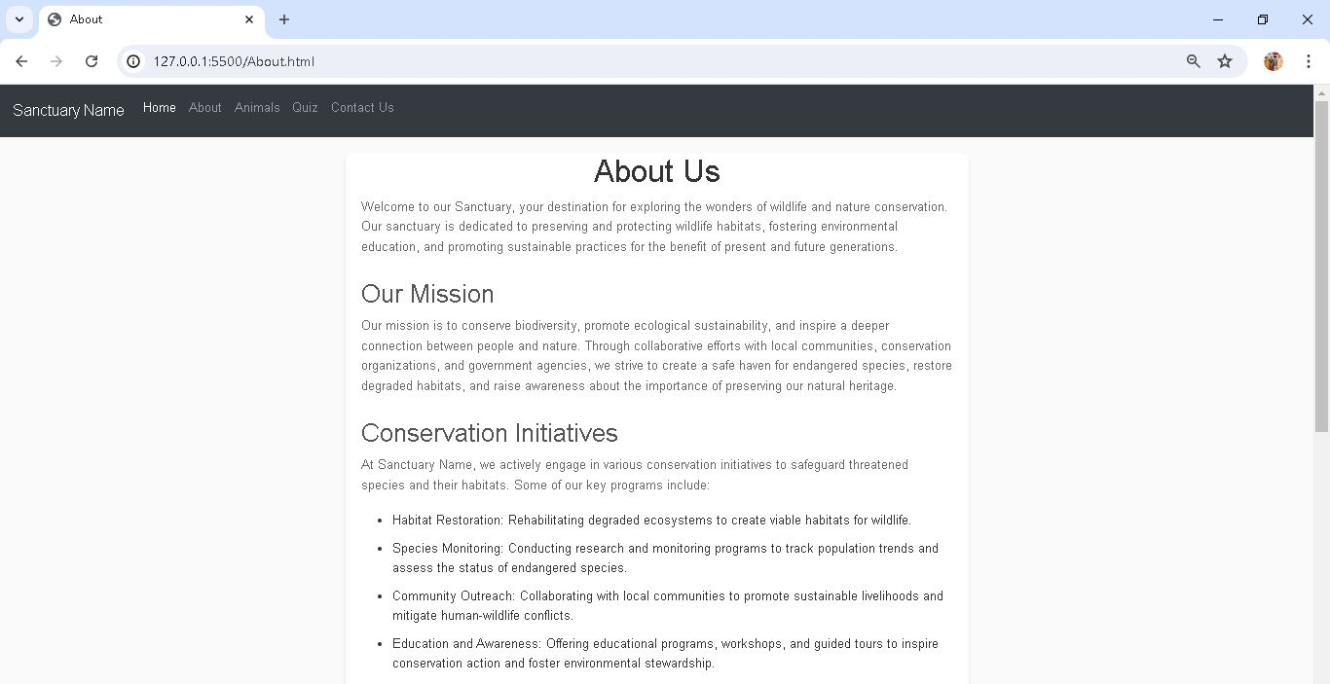

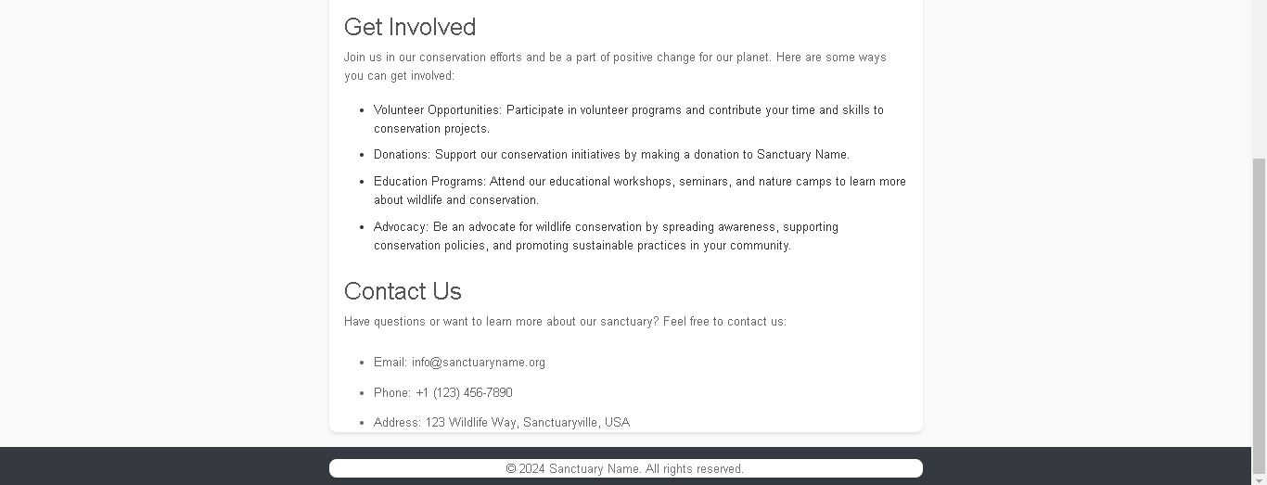

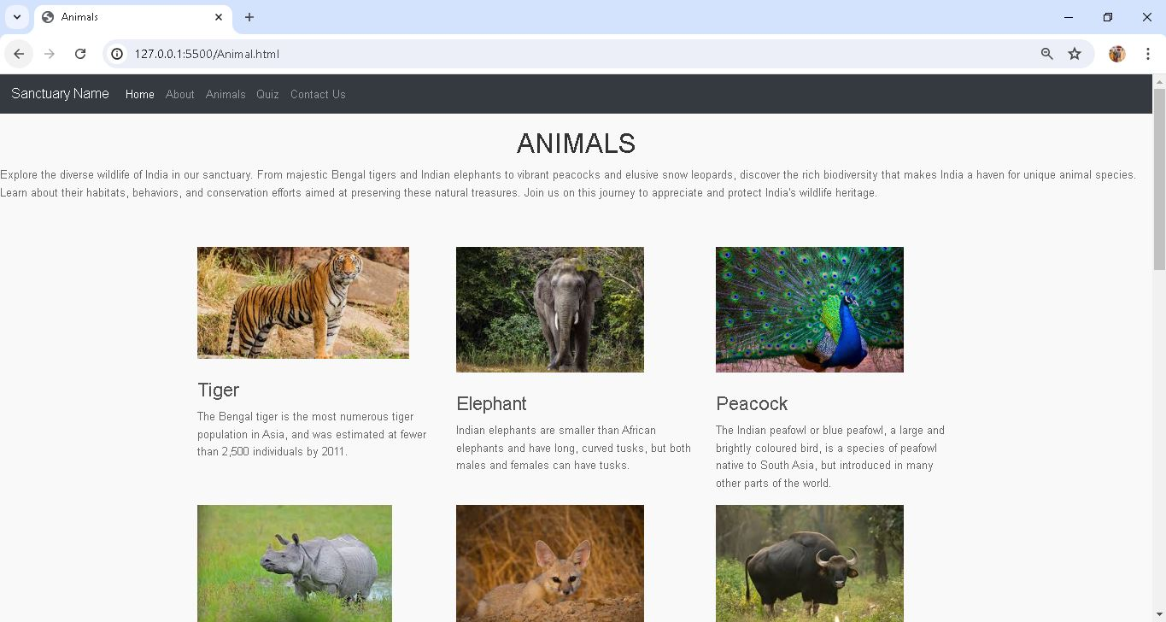

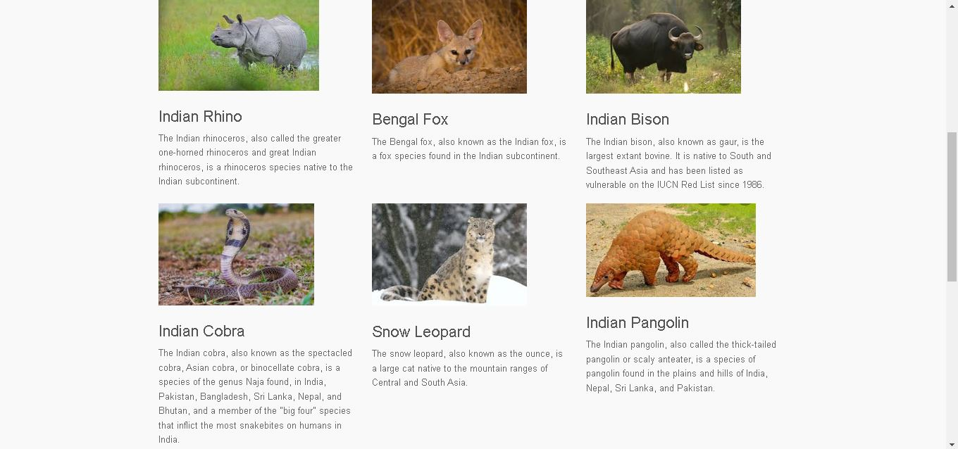

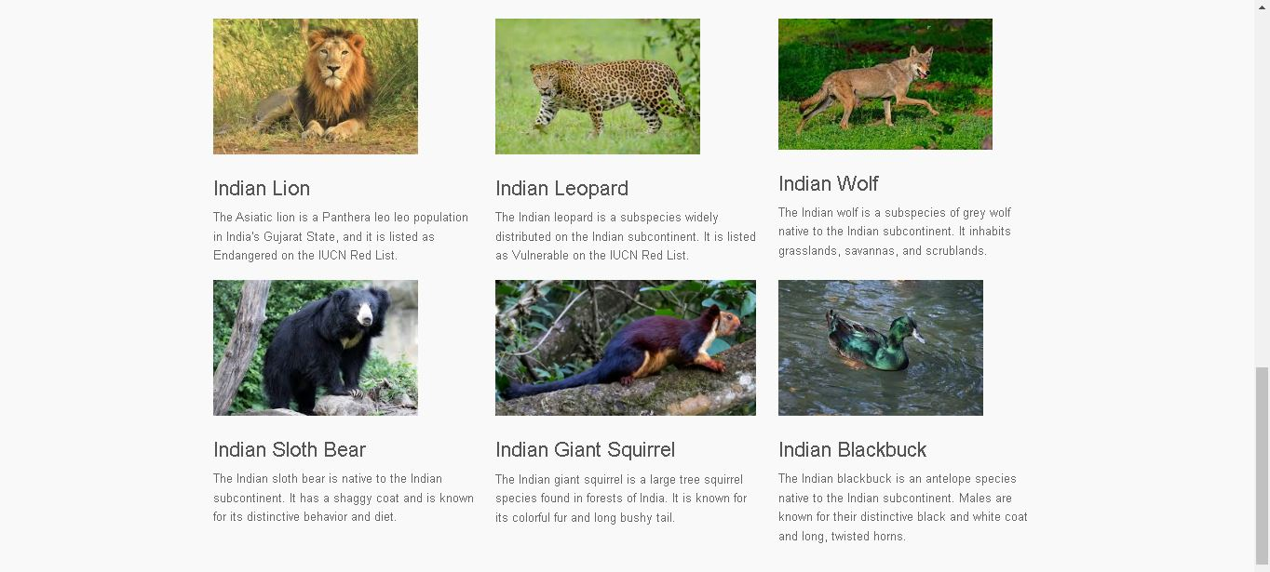

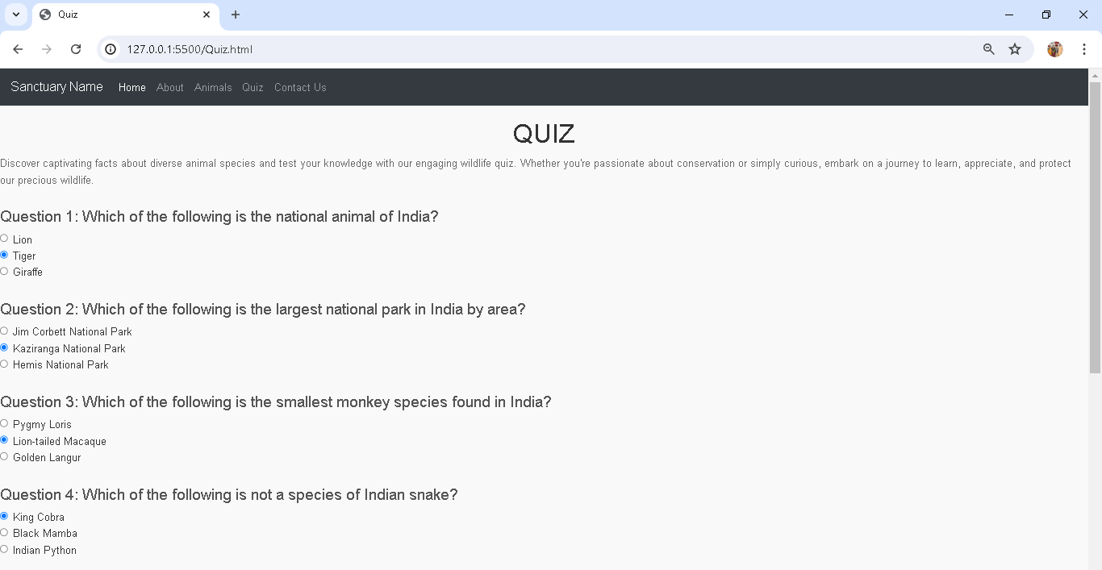

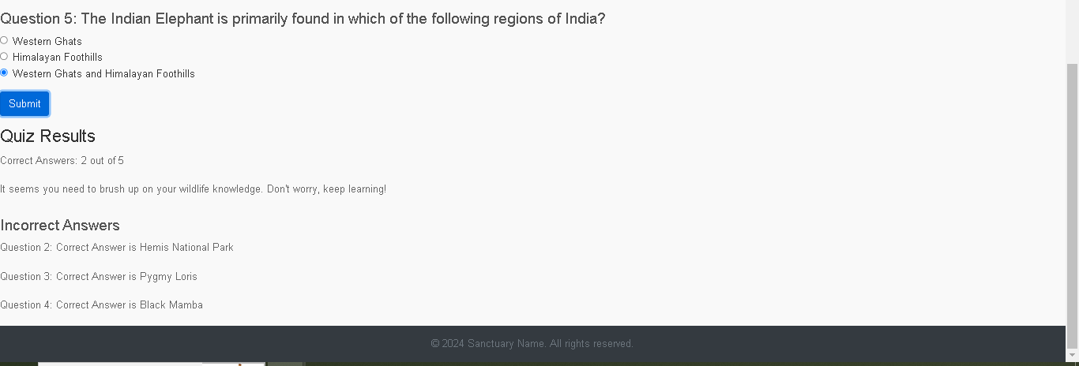

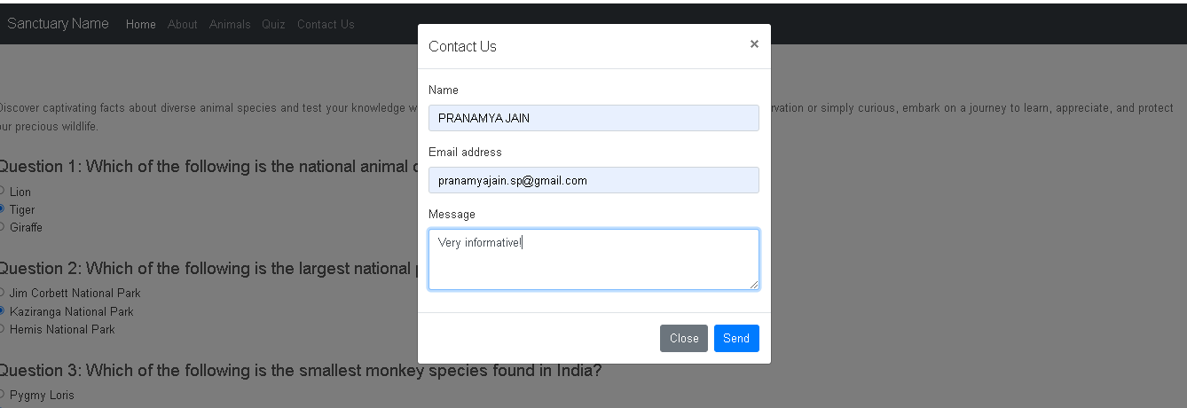

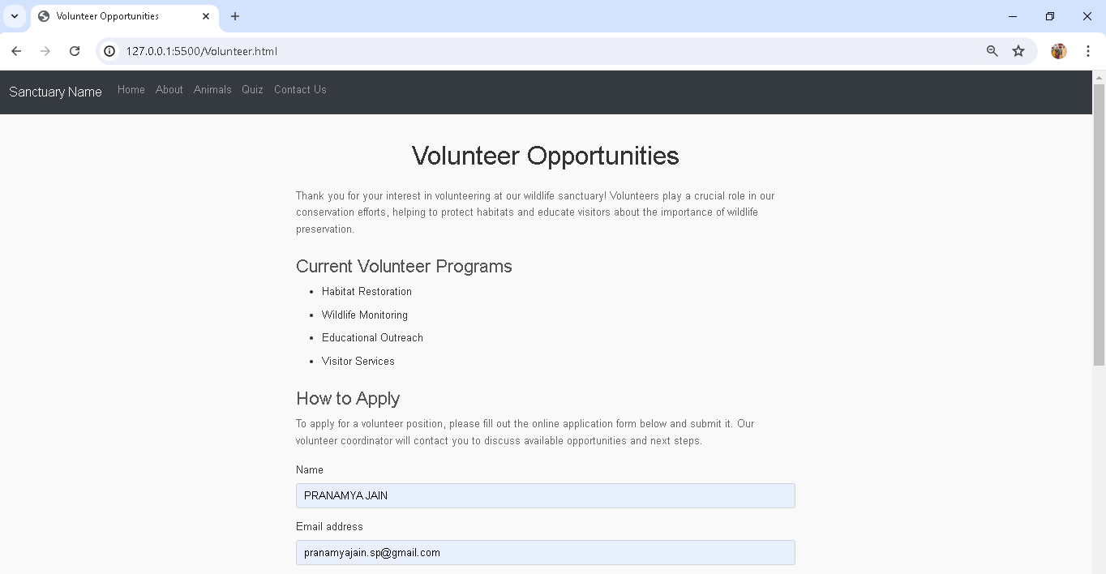

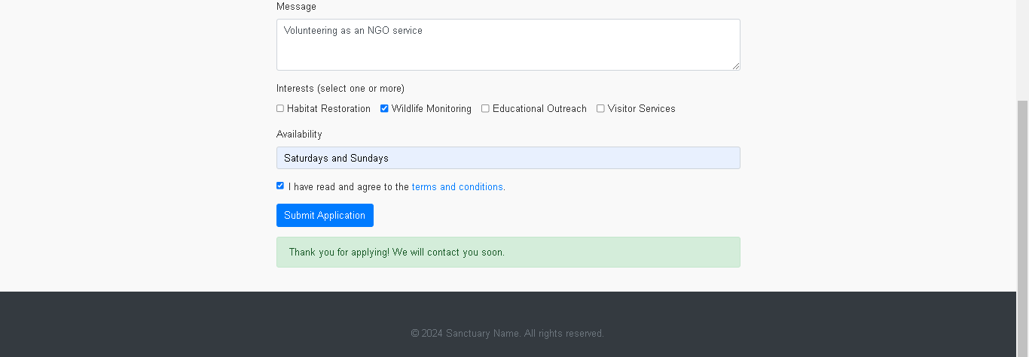

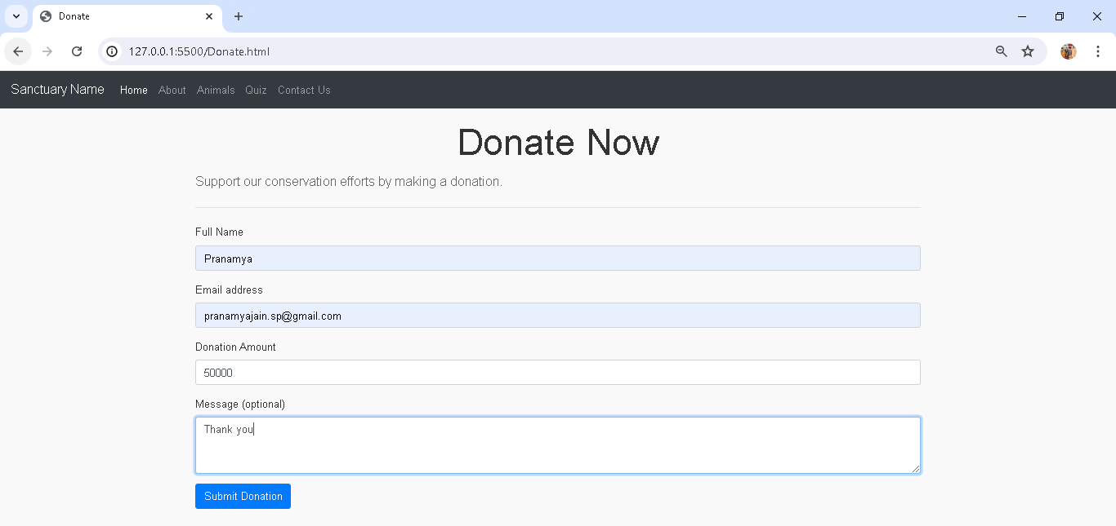

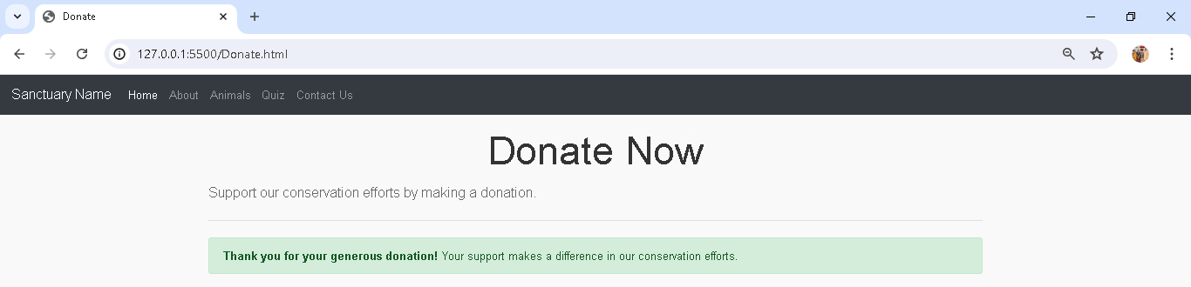

**PHP ASSIGNMENT PROGRAMS**

**1. Write a PHP and MySql program to accept USN, branch, Semester, from web page and display all the students who belong to 6th sem and ECE branch.**

<!DOCTYPE html>

<html lang="en">

<head>

<meta charset="UTF-8">

<meta name="viewport" content="width=device-width, initial-scale=1.0">

<title>Student Database</title>

<style>

body {

font-family: Arial, sans-serif;

margin: 0;

padding: 20px;

}

form {

max-width: 400px;

margin: 0 auto;

padding: 20px;

border: 1px solid #ccc;

border-radius: 10px;

}

label {

display: block;

margin: 10px 0 5px;

}

input[type="text"],

input[type="number"],

input[type="submit"] {

width: 100%;

padding: 8px;

margin: 5px 0 20px;

box-sizing: border-box;

}

button {

width: 100%;

padding: 10px;

background-color: #4CAF50;

color: white;

border: none;

border-radius: 5px;

cursor: pointer;

}

button:hover {

background-color: #45a049;

}

.student-details {

max-width: 600px;

margin: 20px auto;

padding: 10px;

border: 1px solid #ccc;

border-radius: 10px;

display: none;

}

.student-details table {

width: 100%;

border-collapse: collapse;

}

.student-details table,

th,

td {

border: 1px solid black;

padding: 8px;

}

th {

background-color: #f2f2f2;

}

</style>

</head>

<body>

<h1>Student Details</h1>

<form action="students.php" method="post">

<label for="usn">USN:</label>

<input type="text" id="usn" name="usn" required>

<label for="branch">Branch:</label>

<input type="text" id="branch" name="branch" required>

<label for="sem">Semester:</label>

<input type="number" id="sem" name="sem" required>

<input type="submit" value="Add Student">

</form>

<button onclick="showECESixthSemester()">Show ECE 6th Semester Students</button>

<div class="student-details" id="student-details">

<h2>ECE 6th Semester Students</h2>

<table>

<thead>

<tr>

<th>ID</th>

<th>USN</th>

<th>Branch</th>

<th>Semester</th>

</tr>

</thead>

<tbody id="student-details-body">

<!-- Student details will be inserted here -->

</tbody>

</table>

</div>

<script>

function showECESixthSemester() {

fetch('students.php')

.then(response => response.json())

.then(data => {

const studentDetailsBody = document.getElementById('student-details-body');

studentDetailsBody.innerHTML = '';

data.forEach(student => {

const row = document.createElement('tr');

row.innerHTML = `

<td>${student.id}</td>

<td>${student.usn}</td>

<td>${student.branch}</td>

<td>${student.sem}</td>

`;

studentDetailsBody.appendChild(row);

});

document.getElementById('student-details').style.display = 'block';

})

.catch(error => console.error('Error fetching student details:', error));

}

</script>

</body>

</html>

<?php

// Database connection

$servername = "localhost";

$username = "root";

$password = "";

$database_name = "student_db";

// Connect to the database with its name

$conn = new mysqli($servername, $username, $password, $database_name);

if ($conn->connect_error) {

die("Connection failed: " . $conn->connect_error);

}

// Check if the database exists, if not create it

$result = $conn->query("SHOW DATABASES LIKE '$database_name'");

if ($result->num_rows == 0) {

$create_db_sql = "CREATE DATABASE $database_name";

if ($conn->query($create_db_sql) === TRUE) {

echo "Database created successfully. ";

} else {

echo "Error creating database: " . $conn->error . ". ";

}

$conn->select_db($database_name);

}

// Check if the table 'students' exists, if not create it

$table_name = "students";

$table_exists = $conn->query("SHOW TABLES LIKE '$table_name'");

if ($table_exists->num_rows == 0) {

$create_table_sql = "CREATE TABLE students (

id INT AUTO_INCREMENT PRIMARY KEY,

usn VARCHAR(255) NOT NULL,

branch VARCHAR(255) NOT NULL,

sem INT NOT NULL

)";

if ($conn->query($create_table_sql) === TRUE) {

echo "Table created successfully. ";

} else {

echo "Error creating table: " . $conn->error . ". ";

}

}

// Add a new student

if ($_SERVER['REQUEST_METHOD'] === 'POST' && isset($_POST['usn']) && isset($_POST['branch']) && isset($_POST['sem'])) {

$usn = $_POST['usn'];

$branch = $_POST['branch'];

$sem = $_POST['sem'];

$sql = "INSERT INTO students (usn, branch, sem) VALUES ('$usn', '$branch', $sem)";

if ($conn->query($sql) === TRUE) {

echo "Student added successfully.";

} else {

echo "Error: " . $sql . "<br>" . $conn->error;

}

}

// Fetch students with branch ECE and semester 6

if ($_SERVER['REQUEST_METHOD'] === 'GET') {

$sql = "SELECT * FROM students WHERE branch='ECE' AND sem=6";

$result = $conn->query($sql);

$students = array();

if ($result->num_rows > 0) {

while ($row = $result->fetch_assoc()) {

$students[] = $row;

}

}

// Return the student details as JSON

header('Content-Type: application/json');

echo json_encode($students);

}

$conn->close();

?>

**OUTPUTS:**

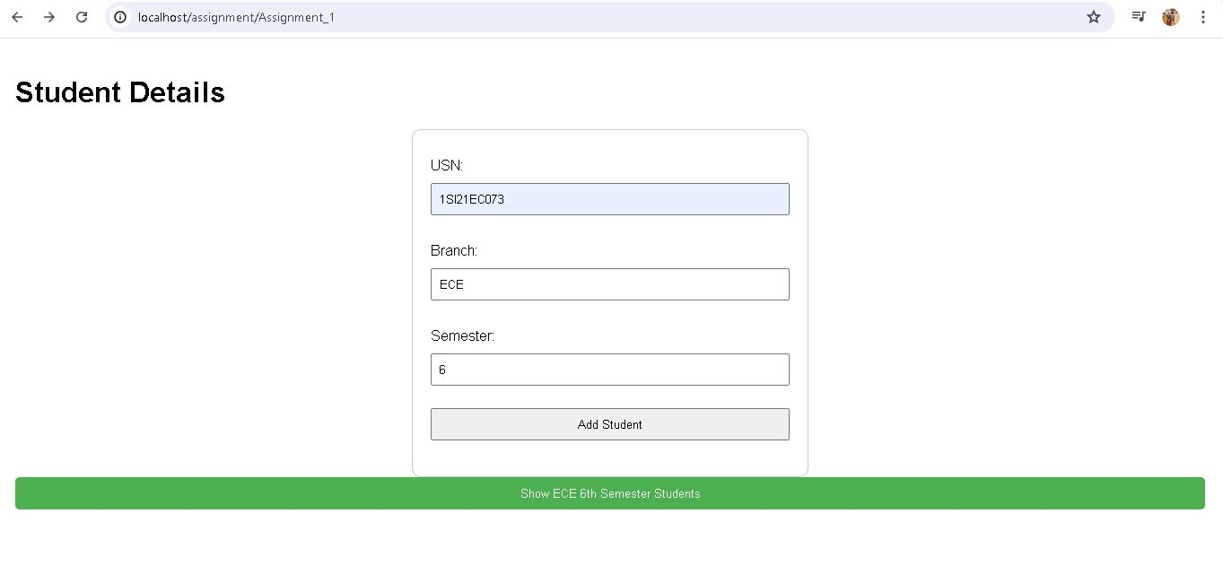

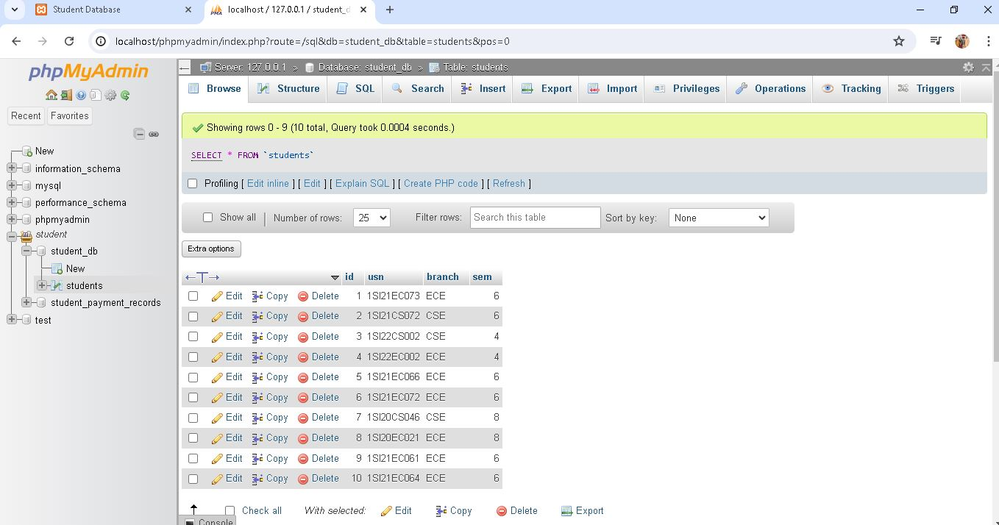

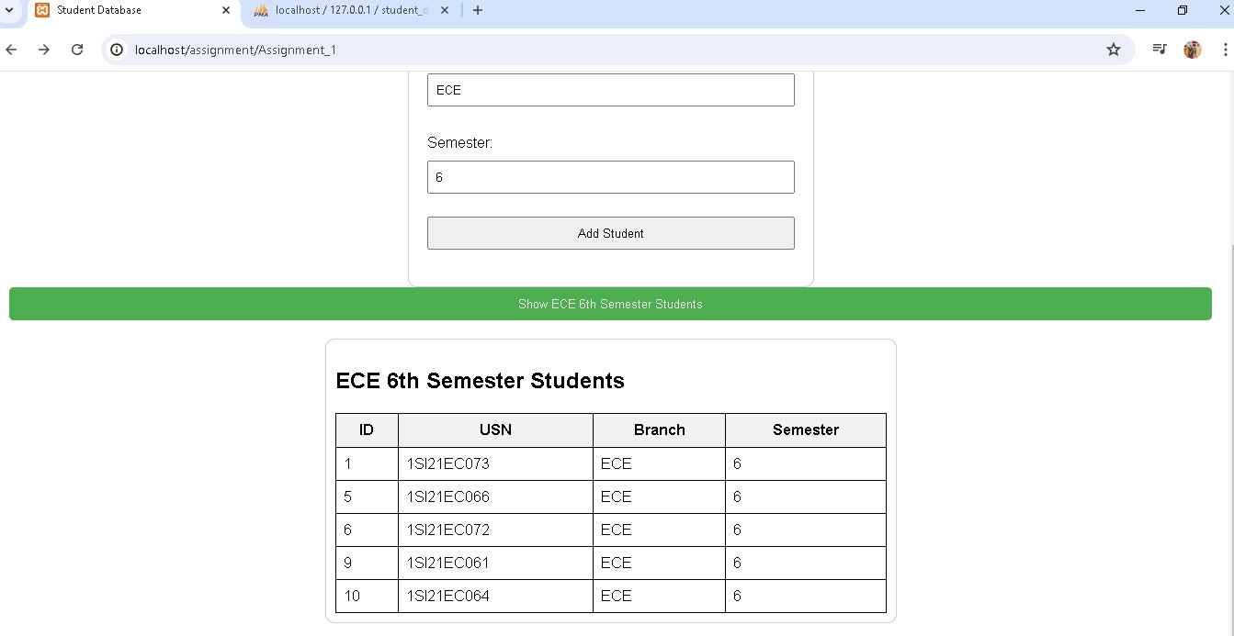

**2. Write a php and MySQL program to accept Student_name,USN,semester,exam_fee from web page and delete all the students who have not paid exam fees.**

<!DOCTYPE html>

<html>

<head>

<title>Student Payment Records</title>

<style>

body {

font-family: Arial, sans-serif;

margin: 20px;

}

h1 {

text-align: center;

}

.container {

display: flex;

justify-content: center;

}

.form-container {

width: 50%;

margin-right: 20px;

}

.records-container {

width: 50%;

}

form {

border: 1px solid #ccc;

padding: 20px;

background-color: #f7f7f7;

}

ul {

list-style: none;

padding: 0;

}

li {

margin: 10px 0;

border: 1px solid #ccc;

padding: 10px;

background-color: #fff;

}

.form-group {

margin-bottom: 10px;

display: flex;

flex-direction: column;

}

.form-group label {

font-weight: bold;

}

.form-group input {

padding: 5px;

border: 1px solid #ccc;

border-radius: 3px;

}

</style>

</head>

<body>

<h1>Student Records</h1>

<div class="container">

<div class="form-container">

<h2>Add Student Record</h2>

<form action="index.php" method="post">

<div class="form-group">

<label for="usn">USN:</label>

<input type="text" name="usn" required>

</div>

<div class="form-group">

<label for="name">Student Name:</label>

<input type="text" name="name" required>

</div>

<div class="form-group">

<label for="semester">Semester:</label>

<input type="text" name="semester" required>

</div>

<div class="form-group">

<label for="exam_fee">Exam Fee:</label>

<input type="number" step="0.01" name="exam_fee" required>

</div>

<button type="submit" name="add_student">Add Student</button>

</form>

<!-- Add a button to delete unpaid students -->

<form action="index.php" method="post">

<button type="submit" name="delete_unpaid_students">Delete Unpaid Students</button>

</form>

</div>

<div class="records-container">

<h2>Student Records</h2>

<ul>

<?php

// Database creation and connection

$servername = "localhost";

$username = "root";

$password = "";

$dbname = "student_payment_records";

$conn = mysqli_connect($servername, $username, $password);

if (!$conn) {

die("Connection failed: " . mysqli_connect_error());

}

// Create the database if it doesn't exist

$sql = "CREATE DATABASE IF NOT EXISTS $dbname";

if (mysqli_query($conn, $sql)) {

$conn = mysqli_connect($servername, $username, $password, $dbname);

// Create the table if it doesn't exist

$createTableSQL = "CREATE TABLE IF NOT EXISTS students (

id INT AUTO_INCREMENT PRIMARY KEY,

usn VARCHAR(10) NOT NULL,

name VARCHAR(50) NOT NULL,

semester VARCHAR(10) NOT NULL,

exam_fee DECIMAL(5, 2) NOT NULL

)";

mysqli_query($conn, $createTableSQL);

}

// Add student record

if (isset($_POST['add_student'])) {

$usn = $_POST['usn'];

$name = $_POST['name'];

$semester = $_POST['semester'];

$exam_fee = $_POST['exam_fee'];

$sql = "INSERT INTO students (usn, name, semester, exam_fee) VALUES ('$usn', '$name', '$semester', $exam_fee)";

if (mysqli_query($conn, $sql)) {

echo "Student record added successfully.";

} else {

echo "Error: " . $sql . "<br>" . mysqli_error($conn);

}

}

// Delete students who have not paid the exam fee

if (isset($_POST['delete_unpaid_students'])) {

$sql = "DELETE FROM students WHERE exam_fee <= 0";

if (mysqli_query($conn, $sql)) {

echo "Deleted students who have not paid the exam fee.";

} else {

echo "Error: " . $sql . "<br>" . mysqli_error($conn);

}

}

// Display all students

$sql = "SELECT usn, name, semester, exam_fee FROM students";

$result = mysqli_query($conn, $sql);

if (mysqli_num_rows($result) > 0) {

while ($row = mysqli_fetch_assoc($result)) {

echo "<li>USN: " . $row["usn"] . ", Name: " . $row["name"] . ", Semester: " . $row["semester"] . ", Exam Fee: $" . $row["exam_fee"] . "</li>";

}

} else {

echo "No student records found.";

}

mysqli_close($conn);

?>

</ul>

</div>

</div>

</body>

</html>

**OUTPUTS:**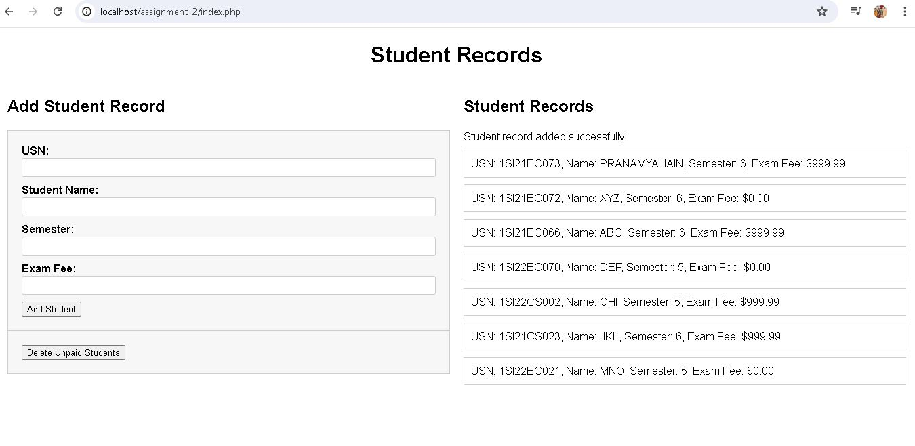

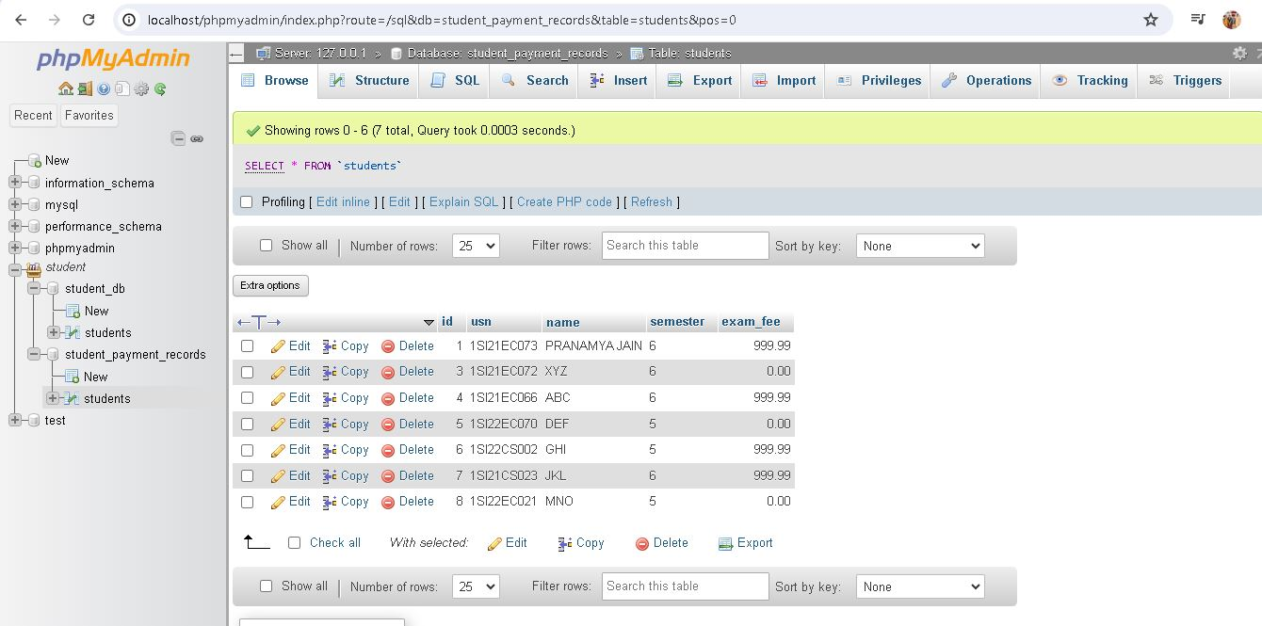

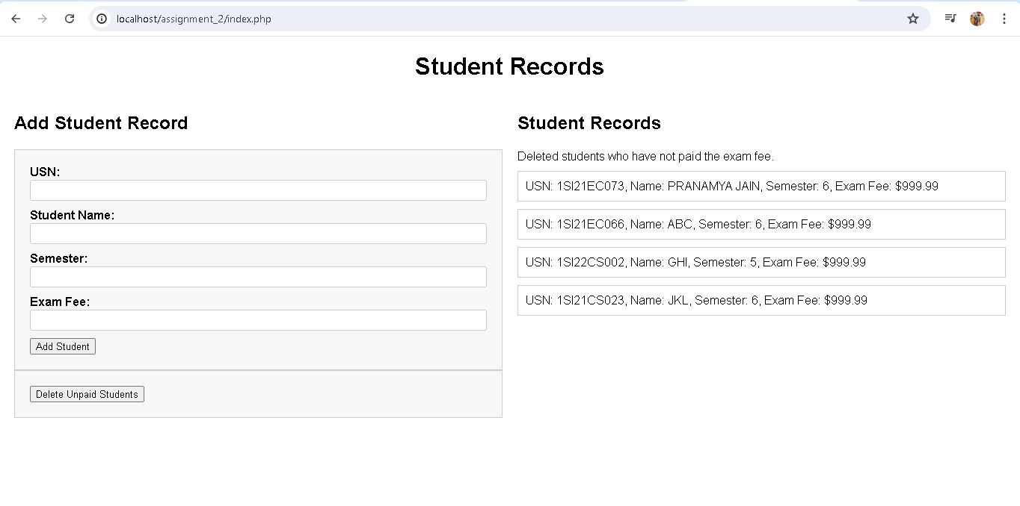

**LIST OF HTML TAGS, CSS PROPERTIES AND DATABASE QUERIES USED**

**List of HTML tags:**

* **<head> :** Contains metadata and links to external resources for the HTML document.
* **<style> :** Contains CSS rules to style the HTML document.
* **<script> :** Embeds or links to a client-side script like JavaScript.
* **<nav> :** Defines a section of navigation links.
* **<a> :** Creates hyperlinks to other web pages,locations within the same page.
* **<ul>:** Defines an unordered list, typically used for listing navigation items or other collections of items.
* **<form> :** Contains interactive controls for user input.
* **<input> :** Represents a control that allows users to enter data
* **<footer> :** Defines a footer for a document or section
* **<div> :** Defines a division or section within an HTML document
* **<modal> :** Represents dialog box displayed over the current page content.
* **<img> :** Embeds an image into the HTML document.

**CSS Properties:**

* **color :** Specifies the text color.
* **padding :** Sets the padding space on all four sides of an element.
* **font-family :** Specifies the font family for text.
* **list-style-type :** Defines the style of the list item marker, such as bullets or numbers.
* **text-decoration :** Specifies decorations added to text, such as underline
* **font-size :** Sets the size of the font.
* **font-weight :** Specifies the thickness of the font characters.
* **text-align :** Aligns text horizontally within its container.

**Database Queries:**

* **Check Database Existence:** Checks if the database with ‘name’ exists.
* **Create Database :** Creates a new database with ‘name’ if it doesn't exist.
* **Select Database :** Selects the database for use.
* **Check Table Existence :** Checks if the table with ‘name’ exists in the selected database
* **Create Table :** Creates a new table with columns if it doesn't exist.
* **Delete Unpaid Students :** Deletes student records from the table.